What Are Database Functions?

Data base functions, allow you to perform operations on an Excel database that involve multiple fields. In a sense, they offer the power of array formulas, but generally make faster worksheets because they do not require the same amount of recalculation.

With database functions you can get counts, averages, or sums of your data based on selection criteria involving multiple fields. Implementing database functions is a little like implementing advanced filters. You have to establish a criteria range first before you use the function itself.

Take the following Excel database as an example.

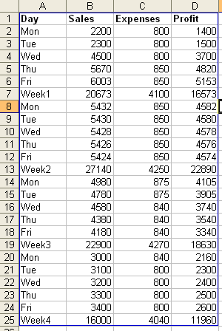
We will use the DSUM database function to calculate the total profit for all Tuesdays and Thursdays with Sales grater than 3000 and Profit less than 4500.

The first step in using a database function is to set up a criteria range. We can set up a criteria range by entering the field headings that we want to use, exactly as they are in the original data list.

For this example, we will need the fields Day, Sales, and Profit for our criteria range. If we enter these field headings in cells F1, G1, and H21 respectively, we can then move on to setting up our criteria.

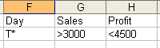

This is the criteria range for the DSUM database function. In the row under the field headings, we have T* >3000 <4500. This means that records with a Day starting with T and Sales greater than 3000 and Profit less than 4500 will be selected for summation. If you wanted to join the criteria with a logical or, you would offset the criteria on separate rows (like an advanced filter).

The next step is to choose a cell (H4) to place the function in. To enter the function, activate the cell and choose Insert->Function, or click the function (fx) button on the formula bar. In the insert function dialogue box, choose DSUM from the database category, to reveal the Function Arguments box.

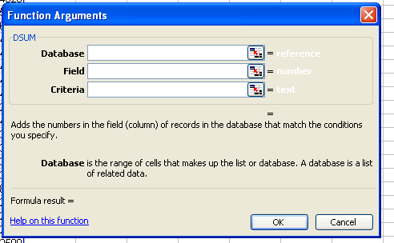
Select your original list with your mouse, or enter the range directly into the Database data area. Press Tab or use your mouse to move to the Field data area and type Profit (this is the field that will be summed).

Put your curser in the Criteria data area, and select the entire criteria range (F1:H2) with your mouse. To finish, click the OK button.
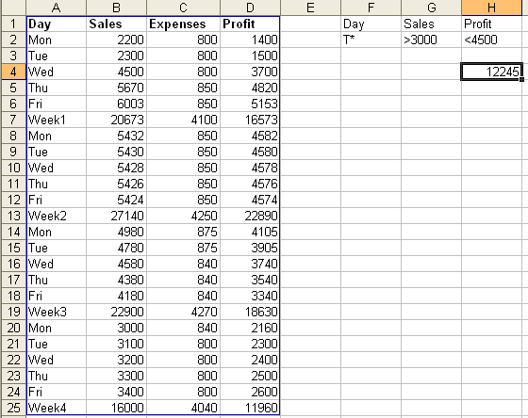

You can see the sum of the Profit fields for records that meet the criteria in cell H4.

You could also activate cell H4 and entered the function directly into the formula bar.

=DSUM(A1:D25,"Profit",F1:H2)

The database range is A1:D25, the field that is being summed is Profit, and the criteria range is F1:H2.

If you enter a database function directly into the formula bar, remember to keep your cell ranges accurate, and put the field that will be summed, averaged, or otherwise operated on, in quotation marks.

Some other useful database functions are,

- DAVERAGE, which is used to average a values in a field based on specified criteria
- DCOUNT Counts the cells that contain numbers and meet the specified criteria
- DMAX and DMIN return the largest and smallest values respectively from records that meet the specified conditions.
- DPRODUCT multiplies values in a field according to specific conditions
- DGET returns a single record value from a record that meets the specified conditions.

All of the data base functions use the same argument format, namely,

Function name(Database range, Field to be returned or calculated, Criteria range).

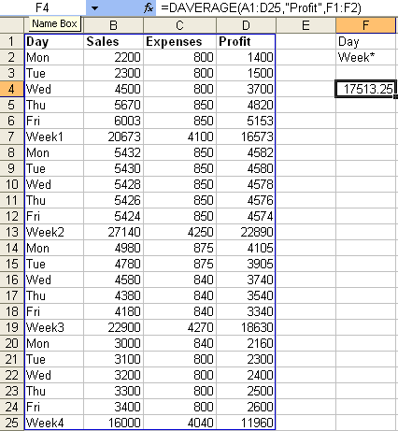
This Image shows the use of the DAVERAGE function. The cell that contains the function is F4, the database range is A1:D25, the field being averaged is Profit, and the criteria range is F1:F2.

The function itself is visible in the formula bar. Notice that the criterion in cell F2 is Week*. This means that the average will be calculated based on the weekly profit figures. (Week* can be Week1, Week2, Week3, and so on).

Creating Subtotals

Another kind of outlining or grouping technique available in Excel is the subtotals feature. If you have some numeric data organized with clear column and row headings, you can use Excel to create automatic subtotals and grand totals for the data.

The following worksheet contains sales information for different products across geographical regions.

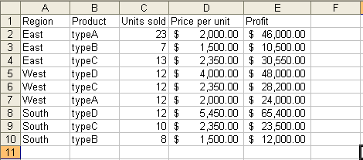

To use Excel’s subtotal feature, select the range of data you want to apply subtotals to, and choose Data->Subtotals from the menu bar. Be sure to include the column labels in your selection, so Excel will be able to discern what numbers to total. For this example, you could select A1:E10 and choose Data->Subtotals to invoke the following subtotals dialogue box.

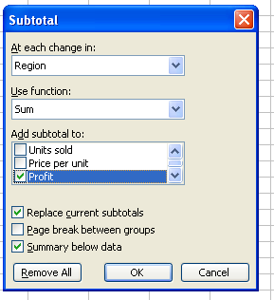
The drop list under the At each change in: heading, gives you options as to the number of rows that will be totalled. (Totals will be applied every time the values under the chosen column label changes.)

The Use function: drop list lets you choose from a list of functions including SUM, AVERAGE, COUNT, PRODUCT, and STDEV to apply to your data. The function you choose, (normally SUM) will be used to calculate the totals.

Under the Add subtotals to: option list, you can select which columns to apply the totals to. You can apply totals to a single column, or to multiple columns in the selected range.

Finally, there are three check boxes at the bottom of the dialogue box that will allow you to:
- Replace any pre existing subtotals
- Put page breaks between totalled groups so they will be printed on separate pages
- Place the subtotals and grand totals above, or below the corresponding data

If you choose to apply totals to each change in region, using the sum function for the profit column, with no page breaks, the resulting worksheet will look like this.

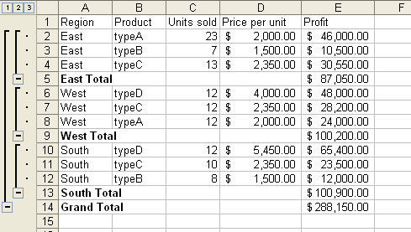

Notice that there is a subtotal for the profit figures at every change in the region value. There is also a grand total for the Profit column at the bottom of the data. You can also that Excel has provided outlined levels, collapse/expand buttons, and numbered outline level buttons associated with the totals. These buttons and outlines work exactly as previously explained. The lower the number on the button, the less detailed information will be shown.

To remove these subtotals, invoke the subtotal dialogue box by choosing Data->Subtotals, and click the Remove All button.

